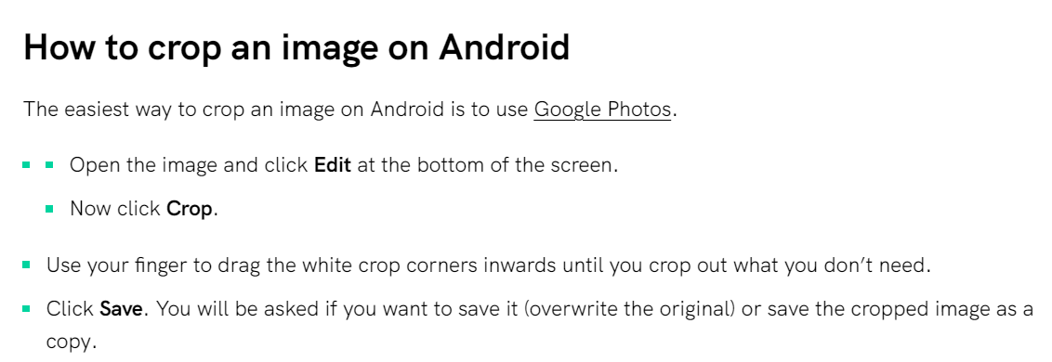
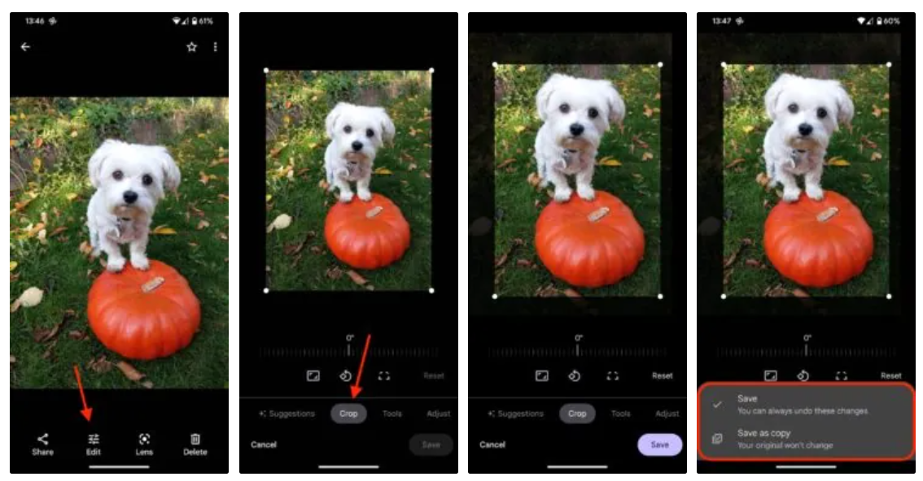
By reducing the size of the picture by a small amount, you will be able to upload photos into MARS that were originally too large to upload.

